# EXPERIMENT 1

**SIMPLE SPEED CONTROL OF DC MOTOR**

**OBJECTIVE**

Observe how the Simple Speed control system is constructed and appreciate the importance of Tacho-generator in closed-loop speed control system

**REFERENCE**

**EXPERIMENT EQUIPMENT**

Following equipment/software is required :

1. OU150A Op Amp Unit
2. AU150B Attenuator Unit
3. PA150C Pre-Amplifier Unit
4. SA150D Servo Amplifier
5. PS150E Power Supply
6. DCM150F DC Motor
7. IP150H Input Potentiometer
8. OP150K Output Potentiometer
9. GT150X Reduction Gear Tacho
10. DC Voltmeter

**PRE-EXPERIMENT TASK**

**INTRODUCTION**

In today'sassignment we shall see how simple speed control of motor could be done. In the experimentinvolving the DC Motor Characteristics we saw how the signal inputs into SA150D could varythe speed of the motor. This means that without any load you can set the motor to run atspecified speed determining the value of the input signal. What kind of speed control was it?Now if we look at the torque/speed characteristics in the experiment, we can say that if load is placed on the motor the speed of the motor will change to some extent. With open-loop system the results show that there can be a reasonable speed control when operating without or with a fixed load but the system would be very unsuitable where the load was varying. With closed load, we will show improvement in speed control with respect to varying load. That is, the actual speed will be compared to the required speed. This produces an error signal to actuate the servo amplifier output so that the motor maintains a more constant speed.

**EXPERIMENT**

**E1. Simple feedback speed-control without load**

In this exercise we will simply feedback a signal proportional to the speed, using the Tachogenerator. We then compare it with a reference signal of opposite polarity, so that the sum will produce an input signal into the servo amplifier of the required value. As comparator, we will use an operational amplifier.

On the OA150A set the 'feedback selector' to 100KΩ resistor

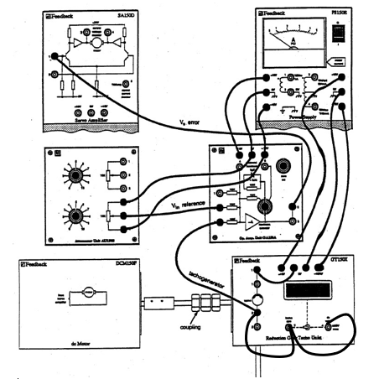

Before connecting the Tacho-generator to an input of the OA150A, increase the 'reference' voltage so that the motor revolves and on your voltmeter determine which the Tacho’s positive output is. The correct side can then be connected to OA150A input and the other side to 0V.

Reset the reference voltage to zero and then gradually increase it so that you can take readings over the motor speed range of upto approximately 2000 r/min for the reference, tacho-generator and error voltages.

**Experiment Data**

|  |  |  |  |
| --- | --- | --- | --- |
| **Speed** | **Reference Voltage** | **Tacho-generator voltage** | **Error Voltage** |
| **200** |  |  |  |
| **400** |  |  |  |
| **600** |  |  |  |
| **800** |  |  |  |
| **1000** |  |  |  |
| **1200** |  |  |  |
| **1400** |  |  |  |
| **1600** |  |  |  |
| **1800** |  |  |  |
| **2000** |  |  |  |

**E2. Effect of Load on Speed**

To find the effect of the load on speed we can user the magnetic brake as a load. The change in speed for a change in load will give us the regulation. Ensure that the eddy current brake disc is fitted to the motor. Also ensure that the load unit can be fully engaged without fouling either the motor mount or the eddy current disc.

The exercise is concerned to show how an increase in the forward path gain will cause a given fall in speed to cause a larger increase in the value of the error V0, so that for any change in load the speed drop or 'droop' will decrease with increase gain as shown in the figure.

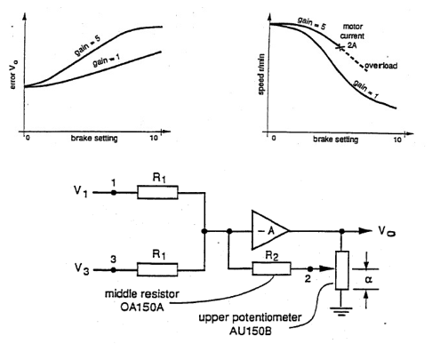

For a gain control we can use the circuit given above, which has a gain of -1/α.

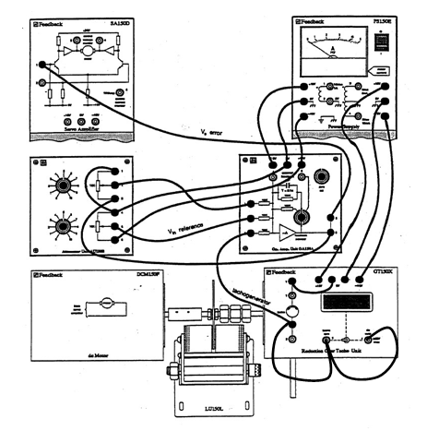

On the OA150A set the 'feedback selector' switch to 'external feedback'. On the LU150L swing the magnets clear. Initially set the gain to unity, that is to position 10 of the upper potentiometer and adjust the reference volts till the motor runs at 1000 r/min. Then take readings of the reference voltage, Vin, Error voltage, Ve and the Tacho-generator voltage, using the voltmeter, over the range of brake positions 0 – 10 and then tabulate your results in the following table. **Be careful that you do not exceed the 2A limiting current**. Repeat the readings for a gain of 5, which is to set the gain potentiometer to position 1. Re-adjust the reference potentiometer to give no-load motor speed of 1000 r/min.

**Experiment Data**

|  |  |  |  |  |  |  |  |  |  |
| --- | --- | --- | --- | --- | --- | --- | --- | --- | --- |
| **For gain of 1** | | | | | **For gain of 5** | | | | |
| Brake Position | Reference (Vin) volts | Tacho- generator volts | Error (Ve)  volts | Speed r/min | Brake Position | Reference (Vin) volts | Tacho- generator volts | Error (Ve)  volts | Speed r/min |
| 1 |  |  |  |  |  |  |  |  |  |
| 2 |  |  |  |  |  |  |  |  |  |
| 3 |  |  |  |  |  |  |  |  |  |
| 4 |  |  |  |  |  |  |  |  |  |
| 5 |  |  |  |  |  |  |  |  |  |
| 6 |  |  |  |  |  |  |  |  |  |
| 7 |  |  |  |  |  |  |  |  |  |
| 8 |  |  |  |  |  |  |  |  |  |
| 9 |  |  |  |  |  |  |  |  |  |
| 10 |  |  |  |  |  |  |  |  |  |

**Additional Task**

Plot your results in the form of graphs of error voltage against brake setting and speed for gain values of 1 and 5.

**E3. Reversible Speed Control**

In the last part of the experiment we will assemble a simple reversible speed control system. From your reading you have seen that a high gain decreases the minimum reference signal needed for the motor to respond so this exercise we will use high gain.

The inputs into the SA150D can drive the motor in opposite directions but both inputs require positive voltages. As the output of the OA 150A varies from positive to negative it is necessary to use the PA150C pre-amplifier unit that is so designed that a negative input gives a positive voltage on output and a negative input gives a positive voltage on the other output with a gain of about 25.

Replace the OA150A with PA150C. Setup as shown in the above figure, adjusting the reference to zero output before coupling to the pre-amplifier. Set the pre-amplifier to **'ac compensation'**, this will reduce the effect of ripple on the tacho-generator signal, which causes instability.

Set the potentiometer on AU150B to 5.

With no load on the motor, now find that you can invert the sign of the reference signal so that you can reverse the direction of the motor rotation, by slowly turning the reference potentiometer knob to either side of the center position 5. Record the reference voltage that just causes the motor to rotate.

|  |  |
| --- | --- |
| **Minimum signal needed for motor response** | |
| **Forward** | **Reverse** |
|  |  |

Set the speed of rotation in one direction to 1000 r/min and then take readings over the brake position 0-10, and record them in the following table. To measure the error voltages place the voltmeter across both the PA150C outputs. Then reverse direction and repeat the readings.

**EXPERIMENT 2**

**ELECTRO-PNEUMATIC CONTROL**

**OBJECTIVE**

Fluid Power takes an important role as a technology in the performance of mechanical work. Industrial field nowadays turn their sight to these mechanism because of many advantages despite of its disadvantages. It is important for engineering student to learn and understand about this concept, so they know what to do in real system.

**REFERENCE**

Anonymous. Pneumatics Control Technology-Chungpa EMT. 2011.

Peter Crosser and Frank Ebel. Pneumatics Basic-Level. 2007

**EQUIPMENT REQUIRED**

PN-7050 Air Service Unit 1 piece

PN-7051 Air distributer 1 piece

PN-7100 3/2-way valve with push button (N.C) 1 piece

PN-7101 3/2-way valve with push button (N.O) 1 piece

PN-7400 Pneumatic single-acting cylinder 1 piece

PN-7602 3/2-Way Single Solenoid Valve(N.C) 1 piece

PN-7610 5/2-Way Double Solenoid Valve 1 piece

PN-7402 Double Acting Cylinder with Air Cushion 1 piece

PN-7570 Electrical Limit Switch module(Left) 1 piece

PN-7570 Electrical Limit Switch module(Right) 1 piece

PN-7302 Different pressure valve (AND) 1 piece

PN-7301 Shuttle valve (OR) 1 piece

PN-7400 Pneumatic single-acting cylinder 1 piece

- Power Supply Module 1 piece

- Switch Module 1 piece

- Relay Module 1 piece

- Compressor 1 piece

- Pneumatic Hose Sufficiently

- Electrical leads Sufficiently

**PRE-EXPERIMENT TASK**

1. What is the difference of Pneumatic and Hydraulic system?
2. Why do we need the valves in that System? Explain briefly!
3. How do the 3/2-way valve and 5/2-way valve works?

**INTRODUCTION**

A pneumatic system is a system that uses compressed air to transmit and control energy. The principles of pneumatics are the same as those for hydraulics, but pneumatics transmits power using a gas instead of a liquid. Compressed air is usually used, but nitrogen or other inert gases can be used for special applications. With pneumatics, air is usually pumped into a receiver using a compressor. The receiver holds a large volume of compressed air to be used by the pneumatic system as needed. Atmospheric air contains airborne dirt, water vapor, and other contaminants, so filters and air dryers are often used in pneumatic systems to keep compressed air clean and dry, which improve reliability and service life of the components and system. Pneumatic systems also use a variety of valves for controlling direction, pressure, and speed of actuators.

Most pneumatic systems operate at pressures of about 100 psi or less. Because of the lower pressure, cylinders and other actuators must be sized larger than their hydraulic counterparts to apply an equivalent force. For example, a hydraulic cylinder with a 2 in. diameter piston (3.14 sq. in. area) and fluid pressure of 1,000 psi can push with 3140 lbs. of force. A pneumatic cylinder using 100 psi air would need a bore of almost 6½ in. (33 sq. in.) to develop the same force. Even though pneumatic systems usually operate at much lower pressure than hydraulic systems do, **pneumatics holds many advantages that make it more suitable for many applications.** Because pneumatic pressures are lower, components can be made of thinner and lighter weight materials, such as aluminum and engineered plastics, whereas hydraulic components are generally made of steel and ductile or cast iron. Hydraulic systems are often considered rigid, whereas pneumatic systems usually offer some cushioning, or “give.” Pneumatic systems are generally simpler because air can be exhausted to the atmosphere, whereas hydraulic fluid usually is routed back to a fluid reservoir.

**Pneumatics also holds advantages over electromechanical power transmission methods.** Electric motors are often limited by heat generation. Heat generation is usually not a concern with pneumatic motors because the stream of compressed air running through them carries heat from them. Furthermore, because pneumatic components require no electricity, they don‟t need the bulky, heavy, and expensive explosion-proof enclosures required by electric motors. In fact, even without special enclosures, electric motors are substantially larger and heavier than pneumatic motors of equivalent power rating. Plus, if overloaded, pneumatic motors will simply stall and not use any power. Electric motors, on the other hand, can overheat and burn out if overloaded. Moreover, torque, force, and speed control with pneumatics often requires simple pressure- or flow-control valves, as opposed to more expensive and complex electrical drive controls. And as with hydraulics, pneumatic actuators can instantly reverse direction, whereas electromechanical components often rotate with high momentum, which can delay changes in direction.

**Factory automation is the largest sector for pneumatics technology**, which is widely used for manipulating products in manufacturing, processing, and packaging operations. **Pneumatics is also widely used in medical and food processing equipment**. Pneumatics is typically thought of as pick-and-place technology, where pneumatic components work in

**is much more.** Because compressed air can have a cushioning effect, it is often called on to provide a gentler touch than what hydraulics or electromechanical drives can usually provide. In many applications, pneumatics is used more for its ability to provide controlled pressing or squeezing as it is for fast and repetitive motion. Moreover, electronic controls can give pneumatic systems positioning accuracy comparable to that of hydraulic and electromechanical technologies.

|  |  |
| --- | --- |
| **1a. Automobile Production Lines** | **1b. Pneumatic system of an automatic machine** |

**Fig. 1(a,b) Common pneumatic systems used in the industrial sector**

Pneumatics is also widely used in chemical plants and refineries to actuate large valves. It‟s used on mobile equipment for transmitting power where hydraulics or electromechanical drives are less practical or not as convenient and in on-highway trucking for various vehicle functions. And of course, vacuum is used for lifting and moving work pieces and products. In fact, combining multiple vacuum cups into a single assembly allows lifting large and heavy objects. Following are the use of pneumatics in a variety of applications i.e. used in controlling train doors, automatic production lines, mechanical clamps, etc.

**Fluid power systems** consist of multiple components that work together or in sequence to perform some action or work. People well versed in fluid power circuit and system design may purchase individual components and assemble them into a fluid power system themselves. However, many fluid power systems are designed by distributors, consultants, and other fluid power professionals who may provide the system in whole or in part. The major components of any fluid power system include:

* **a pumping device** — a hydraulic pump or air compressor to provide fluid power to the system
* **fluid conductors** — tubing, hoses, fittings, manifolds and other components that distribute pressurized fluid throughout the system
* **valves** — devices that control fluid flow, pressure, starting, stopping and direction
* **Actuators** — cylinders, motors, rotary actuators, grippers, vacuum cups and other components that perform the end function of the fluid power system.
* **support components** — filters, heat exchangers, manifolds, hydraulic reservoirs, pneumatic mufflers, and other components that enable the fluid power system to operate more effectively.

Electronic sensors and switches are also incorporated into many of today‟s fluid power systems to provide a means for electronic controls to monitor operation of components. Diagnostic instruments are also used for measuring pressure, temperature and flow in assessing the condition of the system and for troubleshooting.

**EXPERIMENT**

**Experiment 1. Direct and Indirect Control**

Direct control of single acting cylinder using 3/2-way valve with push button.

1. **Operational Procedure**
2. Configure circuit in **Figure 1** for N.C circuit.
3. On the Air Service Unit, adjust the operating pressure in about 2-3 atm. Make sure to always check the pressure control valve in „open‟ or „closed‟ state.
4. Write initial condition of valve when it is depressed and released.
5. Whenever removing hose from device, make sure there isn‟t compressed air that flowing in the hose.
6. Configure circuit in **Figure 2** for N.O circuit.
7. Write initial condition of valve when it is depressed and released.

**EXPERIMENT 3**

**PROGRAMMABLE LOGIC CONTROLLER (PLC) – MITSHUBISHI**

**OBJECTIVE**

Understanding automation process in the industrial field is essential for an engineer. Engineering student have to be used to work and practice in industrial environment.therefore, they are ready with the real system. In this experiment, we will use PLC Mitshubishi

that shows basic automation command clearly and easy to understand. We would have introduced about basic instruction, counter, and timer.

**REFERENCE**

David W. Pessen, Industrial Automation: Circuit Design and Components, 2008.

**EQUIPMENT REQUIRED**

1. What kind of industries that use or apply PLC to their system? Why industries use them?
2. What is company that produces the PLC?

**PRE-EXPERIMENT TASK**

**INTRODUCTION**

**EXPERIMENT**

**EXPERIMENT 4 (Rayhan Haqi)**

**PROCESS CONTROL TRAINER (PCT-100)**